Fireplace Control Circuit Worksheet

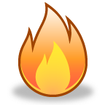
A
B
C
D
Fireplace
Control
Circuit
Gas Line
Emergency
Cut-Off Valve
Thermal
Sensors (4)
The emergency cut-off value should remain open as long as three of the four sensors indicate that a flame is present. (flame=1)

The control circuit (fault indicator) will output a logic (1) when the four sensors do not all agree (i.e., not all on, or not all off). This indicator will be used by the service technician to diagnose whether a faulty sensor exists.
A | B | C | D | Emergency  Cut-Off | Fault  Indicator
0 | 0 | 0 | 0
0 | 0 | 0 | 1
0 | 0 | 1 | 0
0 | 0 | 1 | 1
0 | 1 | 0 | 0
0 | 1 | 0 | 1
0 | 1 | 1 | 0
0 | 1 | 1 | 1
1 | 0 | 0 | 0
1 | 0 | 0 | 1
1 | 0 | 1 | 0
1 | 0 | 1 | 1
1 | 1 | 0 | 0
1 | 1 | 0 | 1
1 | 1 | 1 | 0
1 | 1 | 1 | 1

KMap and write the equations
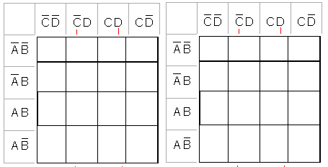
Emergency Cut-Off Valve = Fault Indicator =

Draw what each equation looks like using AOI

Conclusion ( on your own paper )
(minimum 250 words) Describe the process that you used to design, simulate, and build your Fireplace Control Circuit. This conclusion must include all of your design work (i.e., truth table, K-Maps, etc.), preliminary and final schematics, parts list, and a photograph of your final circuit. Be detailed so somebody else could make your circuit following your steps.

